Following error appears when the specified host machine folders “C:\TestAssets” and “C:\TestExecutions” are not included in the docker->settings-> resource ->File Sharing

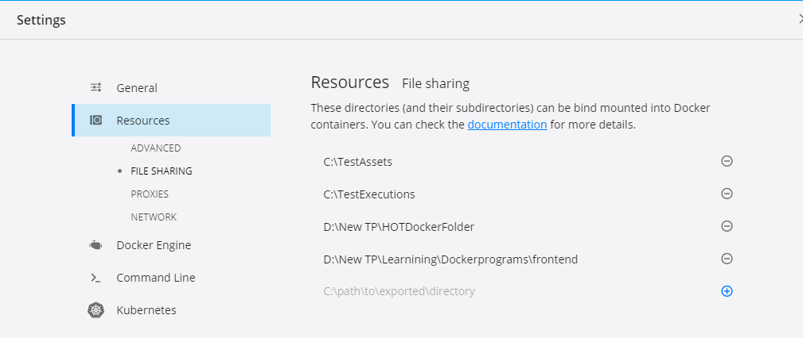

D:\New TP\Installers\HCL_OT_STUDIO_1002_DOCKER_IMG>docker run --rm -e HCL_ONETEST_LICENSING_URL=https:https://hclsoftware-uat.compliance.flexnetoperations.com -e HCL_ONETEST_LICENSING_ID=9XTQMK1YGVTT -v C:\TestAssets:/test -v C:\TestExecutions:/runData -e TEST_IMPORT_PATH=/test/Project.zip hcl-onetest-studio:10.0.2 cmdline -workspace /runData/workspace -project RTWProj1 -suite Tests/Test1.testsuite -results autoResults -stdout -exportlog /runData/logs/WebUItestlog.txt

docker: Error response from daemon: status code not OK but 500: {"Message":"Unhandled exception: Filesharing has been cancelled","StackTrace":" at Docker.ApiServices.Mounting.FileSharing.<DoShareAsync>d__6.MoveNext() in C:\\workspaces\\stable-2.3.x\\src\\github.com\\docker\\pinata\\win\\src\\Docker.ApiServices\\Mounting\\FileSharing.cs:line 0\r\n--- End of stack trace from previous location where exception was thrown ---\r\n at System.Runtime.ExceptionServices.ExceptionDispatchInfo.Throw()\r\n at System.Runtime.CompilerServices.TaskAwaiter.HandleNonSuccessAndDebuggerNotification(Task task)\r\n at Docker.ApiServices.Mounting.FileSharing.<ShareAsync>d__4.MoveNext() in C:\\workspaces\\stable-2.3.x\\src\\github.com\\docker\\pinata\\win\\src\\Docker.ApiServices\\Mounting\\FileSharing.cs:line 47\r\n--- End of stack trace from previous location where exception was thrown ---\r\n at System.Runtime.ExceptionServices.ExceptionDispatchInfo.Throw()\r\n at System.Runtime.CompilerServices.TaskAwaiter.HandleNonSuccessAndDebuggerNotification(Task task)\r\n at Docker.HttpApi.Controllers.FilesharingController.<ShareDirectory>d__2.MoveNext() in C:\\workspaces\\stable-2.3.x\\src\\github.com\\docker\\pinata\\win\\src\\Docker.HttpApi\\Controllers\\FilesharingController.cs:line 21\r\n--- End of stack trace from previous location where exception was thrown ---\r\n at System.Runtime.ExceptionServices.ExceptionDispatchInfo.Throw()\r\n at System.Runtime.CompilerServices.TaskAwaiter.HandleNonSuccessAndDebuggerNotification(Task task)\r\n at System.Threading.Tasks.TaskHelpersExtensions.<CastToObject>d__1`1.MoveNext()\r\n--- End of stack trace from previous location where exception was thrown ---\r\n at System.Runtime.ExceptionServices.ExceptionDispatchInfo.Throw()\r\n at System.Runtime.CompilerServices.TaskAwaiter.HandleNonSuccessAndDebuggerNotification(Task task)\r\n at System.Web.Http.Controllers.ApiControllerActionInvoker.<InvokeActionAsyncCore>d__1.MoveNext()\r\n--- End of stack trace from previous location where exception was thrown ---\r\n at System.Runtime.ExceptionServices.ExceptionDispatchInfo.Throw()\r\n at System.Runtime.CompilerServices.TaskAwaiter.HandleNonSuccessAndDebuggerNotification(Task task)\r\n at System.Web.Http.Controllers.ActionFilterResult.<ExecuteAsync>d__5.MoveNext()\r\n--- End of stack trace from previous location where exception was thrown ---\r\n at System.Runtime.ExceptionServices.ExceptionDispatchInfo.Throw()\r\n at System.Runtime.CompilerServices.TaskAwaiter.HandleNonSuccessAndDebuggerNotification(Task task)\r\n at System.Web.Http.Dispatcher.HttpControllerDispatcher.<SendAsync>d__15.MoveNext()"}.

See 'docker run --help'.

Working command for Running test in the dockerized work-bench

docker run --rm -e HCL_ONETEST_LICENSING_URL=https:https://hclsoftware-uat.compliance.flexnetoperations.com -e HCL_ONETEST_LICENSING_ID=9XTQMK1YGVTT -v C:\TestAssets:/test -v C:\TestExecutions:/runData -e TEST_IMPORT_PATH=/test/Project.zip hcl-onetest-studio:10.0.2 cmdline -workspace /runData/workspace -project RTWProj1 -suite Tests/Test1.testsuite -results autoResults -stdout -exportlog /runData/logs/WebUItestlog.txt